UC-11: Schedule Patient Appointment
Receptionist schedules a new appointment for a patient with a doctor/nurse.

Activity Diagram:
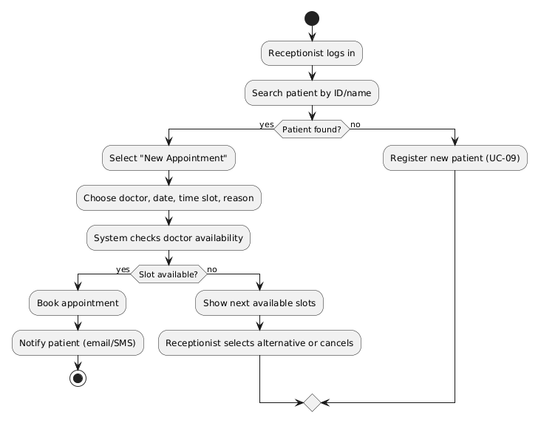

Sequence Diagram:
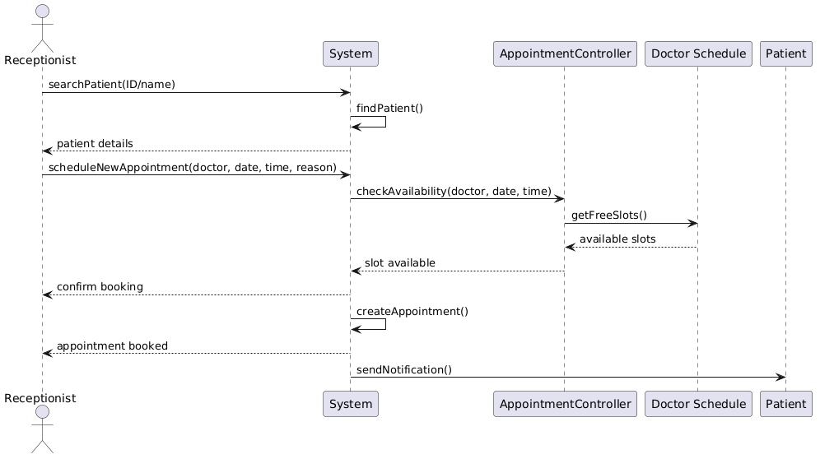

Collaboration Diagram:
